

**REPUBLIC OF CAMEROON**

**Peace-Work-Fatherland**

**MINISTER OF HIGHER EDUCATION**

**FACULTY OF ENGINEERING**

**AND TECHNOLOGY**

**REPUBLIQUE DU CAMEROON**

**PAIX-Travail-Patrie**

**MINISTRE DE L’ENSEIGNEMENT SUPERIEUR**

**FACULTE DE L’ENGINERIE**

**ET TECHGNOLOGIE**

***\*\*\*\*\*\*\*\*\*\*\*\*\*\*\*\*\*\*\*\*\*\** UNIVERSITY OF BUEA *\*\*\*\*\*\*\*\*\*\*\*\*\*\*\*\*\*\*\*\*\*\*\*\*\****

**DEPARTMENT OF COMPUTER ENGINEERING**

**COURSE: INTERNET PROGRAMMING (J2EE) AND MOBILE PROGRAMMING**

**COURSE CODE: CEF 440**

**TASK 2: REQUIREMENT GATHERING**

**PRESENTED BY**

**GROUP 20**

**INSTRUCTOR: DR. VALERY APRIL 2024**

**GROUP MEMBERS**

|  |  |  |
| --- | --- | --- |
| S/N | **Name** | Matricule Number |
| 1 | DUESENBERRY MBIKANG AGBORTAR AKO | FE21A175 |
| 2 | FOTABONG FUALEFAC PUISSANCE | FE21A195 |
| 3 | ABANGMA ARRAH JESUS MCLOUIS | FE21A124 |
| 4 | TABOT JOEL EBANGHA | FE21A308 |
| 5 | EBOMESUMBE NGOLE DANDY BRADLEY | FE21A177 |

Contents

**I - INTRODUCTION** 3

**II SURVEYS** 4

**2.1. VICTIMS** 4

**2.1.1 Problems Faced** 4

**2.1.2 Types of Assistance Sought** 4

**2.1.3 Features Considered Useful by Victims When Developing our Application:** 5

**2.1.4 Google Forms Summary For the Responses Gotten From Questions which were asked:** 5

**2.2. RESPONDENTS** 10

**2.2.1 Respondents' Specialties in Case of a Disaster** 10

**2.2.2 Features to Enhance in the System** 10

**2.2.3 Challenges Faced in Accessing Affected Areas** 10

**2.2.4 Challenges Faced in Communication** 11

**2.2.5 Google Forms Summary For the Responses Gotten From Questions which were asked:** 11

**2.3 AUTHORITIES** 15

**2.3.1 Features which they would Prioritize in the Disaster Management App** 16

**2.3.2 Challenges Faced** 16

**2.3.3 Google Forms Summary For the Responses Gotten From Questions which were asked:** 16

**III - CONCLUSION** 22

# **I - INTRODUCTION**

Disaster management is a critical process that involves the planning, coordination, and implementation of strategies to mitigate the impact of natural or man-made disasters. In today's digital age, the development of a robust disaster management system is essential to facilitate efficient response and recovery efforts. A well-designed disaster management system can help authorities and response teams effectively address emergencies, minimize loss of life and property, and enhance overall community resilience. To ensure the successful development of a disaster management system, it is crucial to gather comprehensive requirements that align with the needs and challenges faced by authorities, victims and respondents. The requirements gathering process involves identifying the key features and functionalities that the system should possess to support effective disaster management operations.

# **II SURVEYS**

To ensure that our system should be as effective as possible we carried out surveys with the various stakeholders i.e Victims, Respondents and Authorities and here are our findings;

## **2.1. VICTIMS**

The data collected from our survey of victims can be found here: <https://docs.google.com/spreadsheets/d/1jhs1I20Tnb9pd45mdeDoBmpoOGGal6WPYekCVZi4Rh4/edit?resourcekey#gid=189836550>

Those who have suffered from previous disasters

### **2.1.1 Problems Faced**

* **Lack of Awareness:**

The lack of awareness among victims was a significant issue which hindered the effectiveness of response and recovery efforts. When individuals affected by a disaster were unaware of the appropriate actions to take, safety protocols, available resources, and the status of ongoing response operations, it lead to confusion, panic, and potential harm.

* **Network Issues:**

Network issues significantly impacted the effectiveness of a disaster affected people. During the disaster, various network-related challenges arose, hindering communication, access to information, and the overall Functionality.

* **Lack of Finance and Needs:**

Financial challenges during a disaster severely impacted victims. Limited access to resources hindered their ability to secure basic necessities like food, water, and shelter. The absence of financial support increased vulnerability, making it difficult to recover and rebuild their lives. The lack of funds also impeded access to healthcare and vital services, exacerbating the physical and emotional toll of the disaster. Ultimately, these financial hardships lead to prolonged recovery process and hindered overall well-being.

### **2.1.2 Types of Assistance Sought**

* **Medical Assistance:**

Medical assistance during disasters plays a crucial role in saving lives and mitigating the impact of injuries and illnesses. Timely medical support is essential to address immediate health needs, provide emergency care, and prevent further complications. However, victims faced challenges in accessing such assistance. Disrupted transportation networks, damaged healthcare infrastructure, and overwhelmed medical facilities hindered the timely arrival of medical personnel and supplies. Additionally, the influx of patients strained the capacity of healthcare systems, leading to delays in receiving treatment. These challenges exacerbated injuries and illnesses, increased the risk of infection, and prolonged the recovery process for disaster victims.

* **Safety Tips:**

Safety tips and guidelines are crucial in helping disaster victims protect themselves and minimize risks during and after such events. These recommendations aim to enhance personal safety, reduce vulnerability, and promote resilience. However due to lack of this information the victims suffered.

* **Evacuation Routes:**

Having access to accurate and up-to-date evacuation routes is of utmost significance in ensuring safe and efficient evacuations during disasters. Poor planning meant little or no evacuation routes only increasing the danger on their lives.

* **Shelters:**

No shelters to hide under or carry injured victims to meant more damage and loss of human life.

### **2.1.3 Features Considered Useful by Victims When Developing our Application:**

* **Easy-to-Use Interface:** The application's user interface should be designed to be simple, intuitive, and visually appealing, with clear navigation and easily accessible features.
* **Offline Functionalities:** The application should offer offline access to essential information, such as safety tips, emergency contacts, and previously accessed data, to ensure usability in areas with poor network coverage.
* **Quick Access to Emergency Contacts:** The application should provide a dedicated section or feature for storing and accessing important emergency contacts, allowing users to quickly reach out for assistance.
* **Real-Time Updates on Disaster Situations:** The application should provide real-time updates on disaster situations, including alerts, warnings, and updates from relevant authorities, ensuring timely and accurate information dissemination.

### **2.1.4 Google Forms Summary For the Responses Gotten From Questions which were asked:**

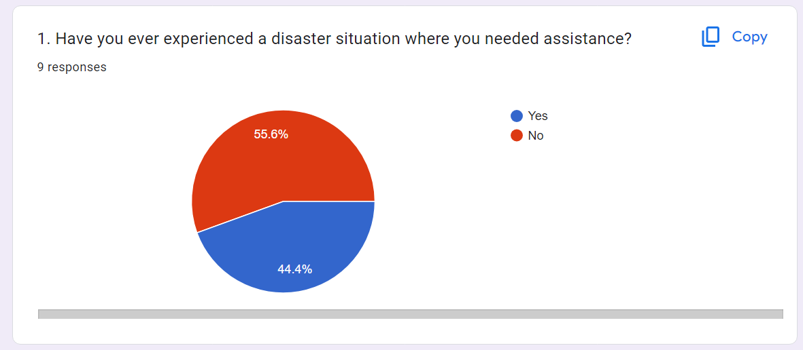

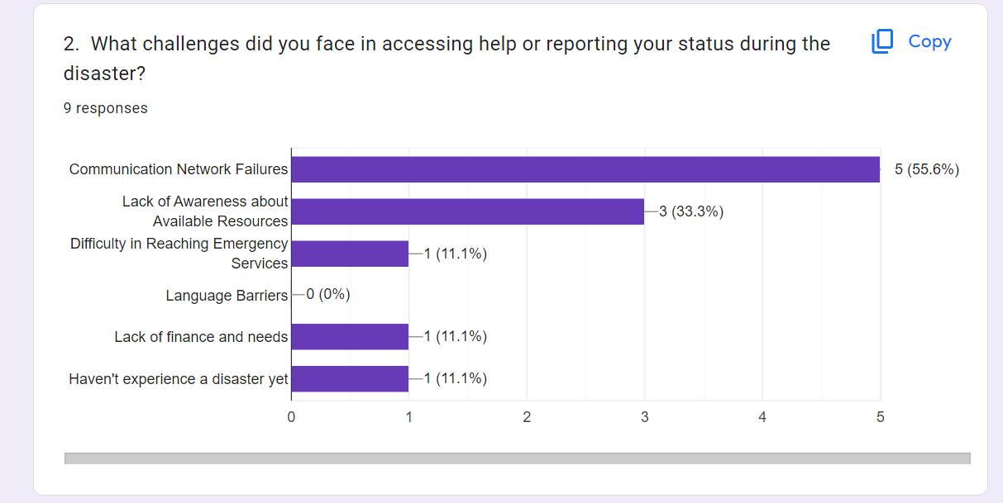

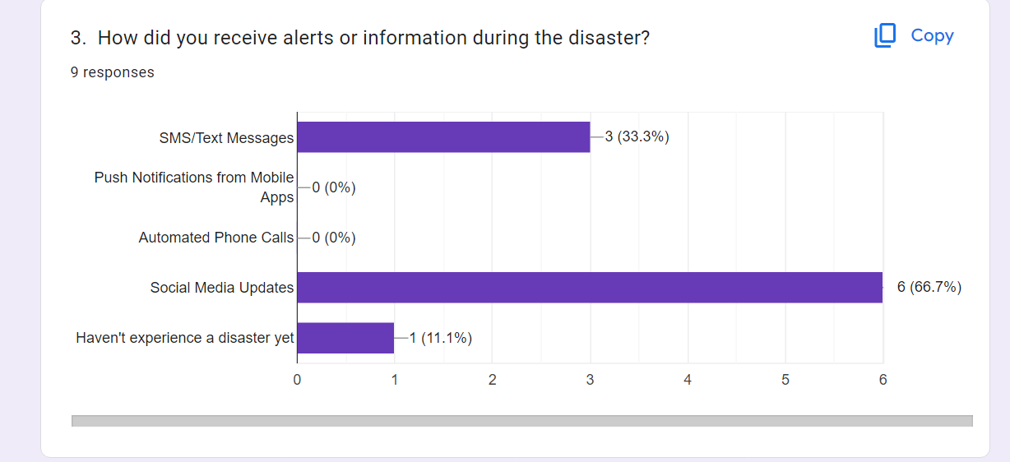

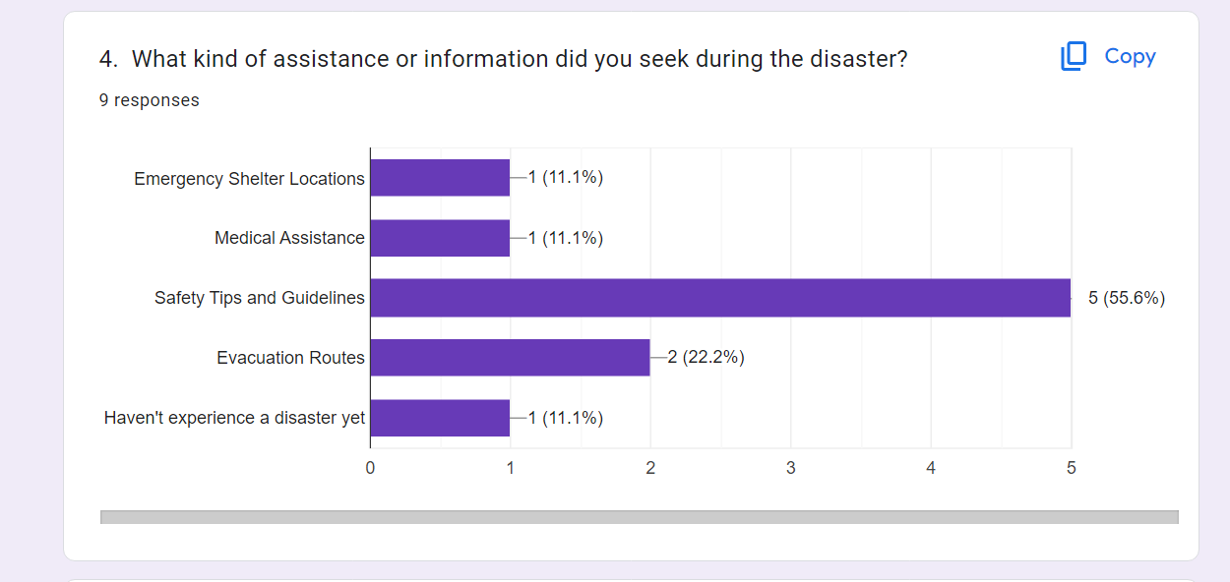

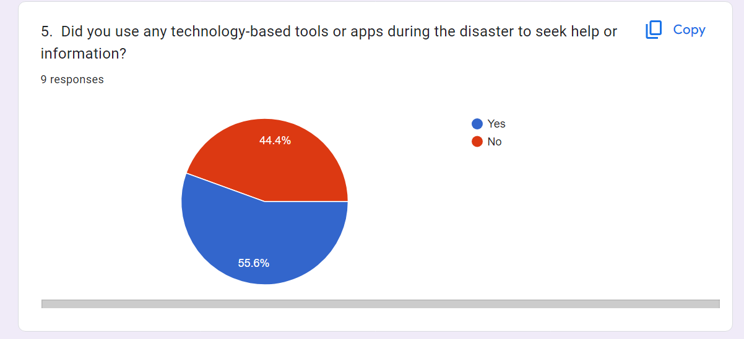

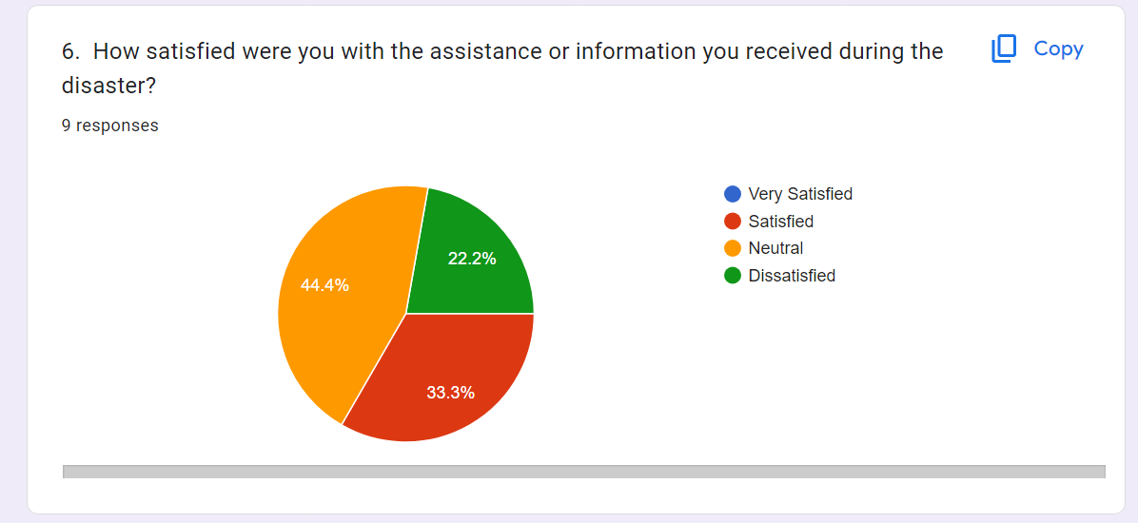

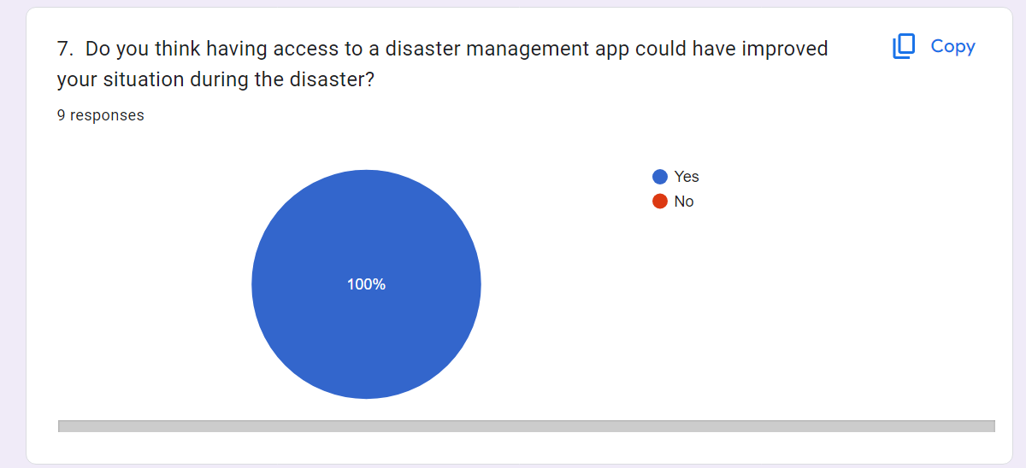

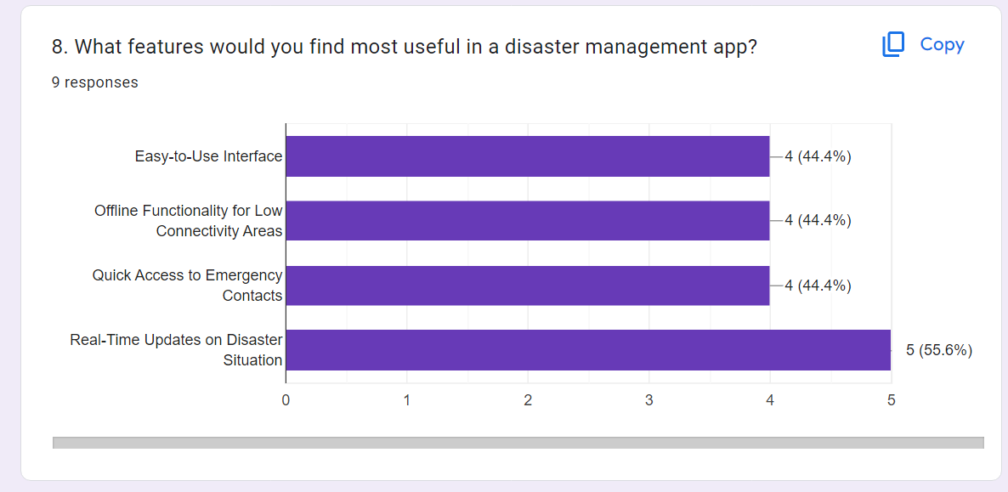

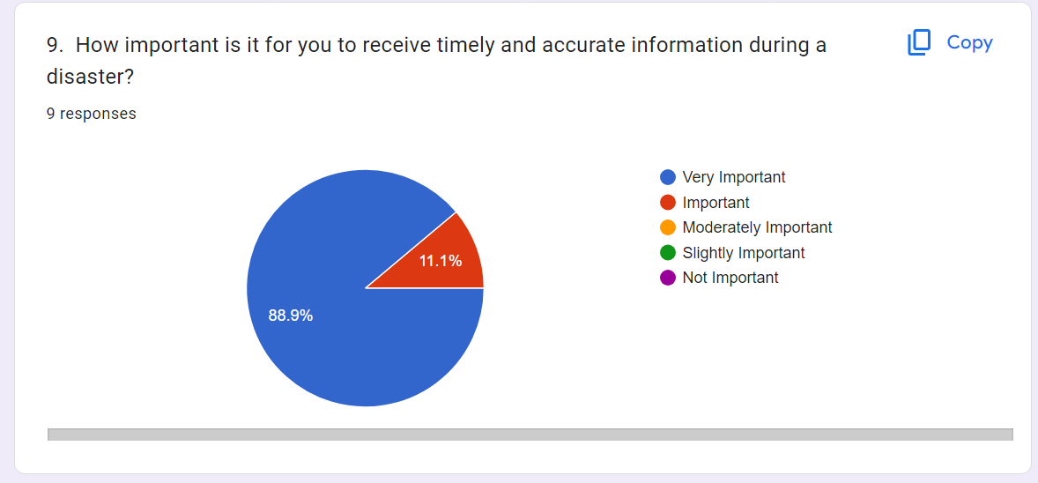

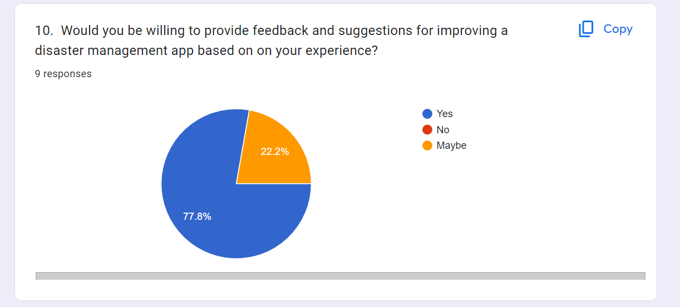

## **2.2. RESPONDENTS**

The data collected from our survey of respondents can be found here: [https://docs.google.com/spreadsheets/d/1gOrO8YO7-rgPAXPJCNN0gUdCDsE47KJtPJE936fg6DU/edit?resourcekey#gid=1961890292](https://docs.google.com/spreadsheets/d/1gOrO8YO7-rgPAXPJCNN0gUdCDsE47KJtPJE936fg6DU/edit?resourcekey" \l "gid=1961890292)

This encompasses all personnels who Respond to disaster situations

### **2.2.1 Respondents' Specialties in Case of a Disaster**

* Medical Training: Most respondents are trained in the field of medicine so there was a huge chunk of medical personnels
* Technological Training: The other majority of the respondents were made up of tech Savy people

### **2.2.2 Features to Enhance in the System**

* **Real-Time Maps and Data Visualization**: Real-time maps that display the affected areas, critical infrastructure, evacuation routes, and other relevant data, allowing users to visualize the disaster situation and make informed decisions would go a long way.
* **Live Video Feeds:** Live video feed capabilities, allowing users to stream and share video footage of the affected areas, incidents, and ongoing rescue operations.
* **Incident Reporting Tools**: The application should include incident reporting tools that allow users to document incidents, attach relevant media (photos, videos), and track the status and resolution of reported incidents.
* **Historical Data Analysis:** Tools for analyzing historical data, including past incidents, response efforts, and outcomes, to identify trends, improve preparedness strategies, and enhance decision-making.

### **2.2.3 Challenges Faced in Accessing Affected Areas**

* Blocked Roads/Infrastructure Damage.
* Lack of Accurate Information on Affected Areas
* Resource Limitations

### **2.2.4 Challenges Faced in Communication**

* Lack of Communication Platforms
* Language Barrier

### **2.2.5 Google Forms Summary For the Responses Gotten From Questions which were asked:**

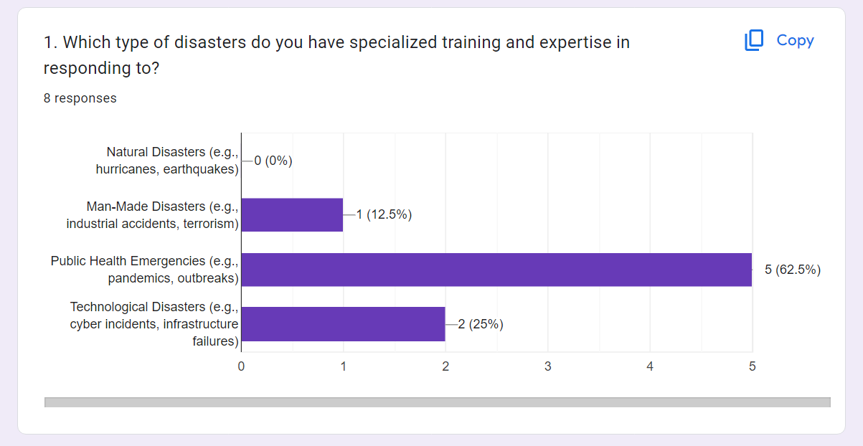

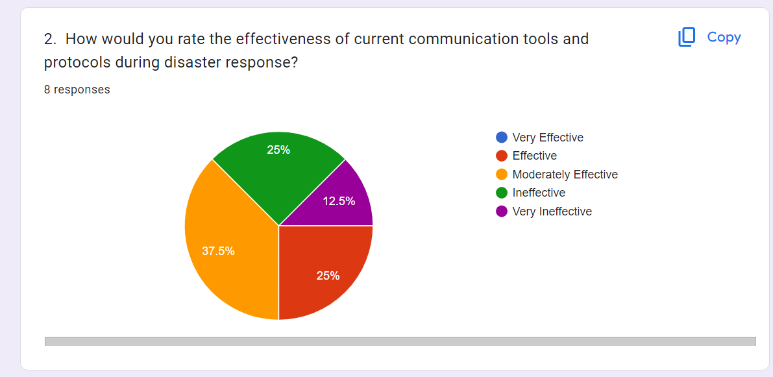

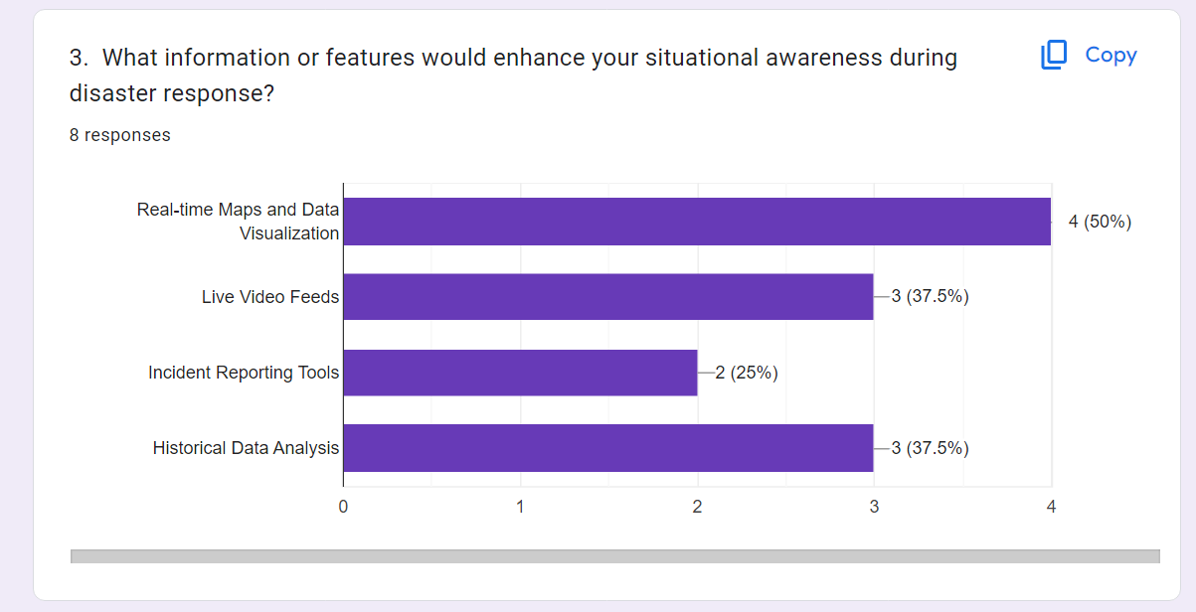

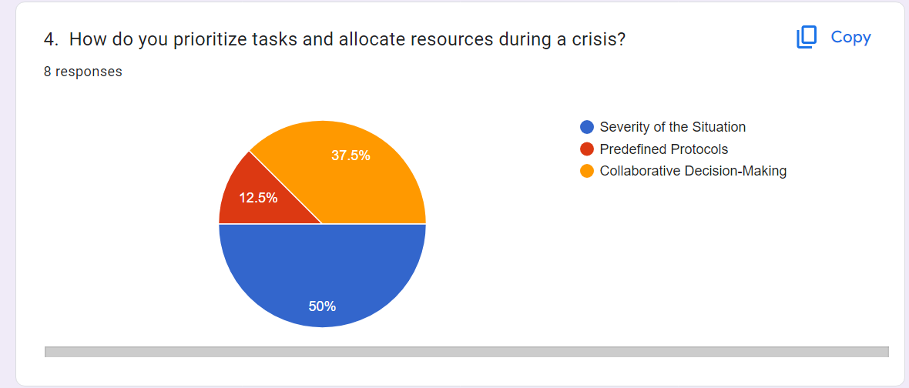

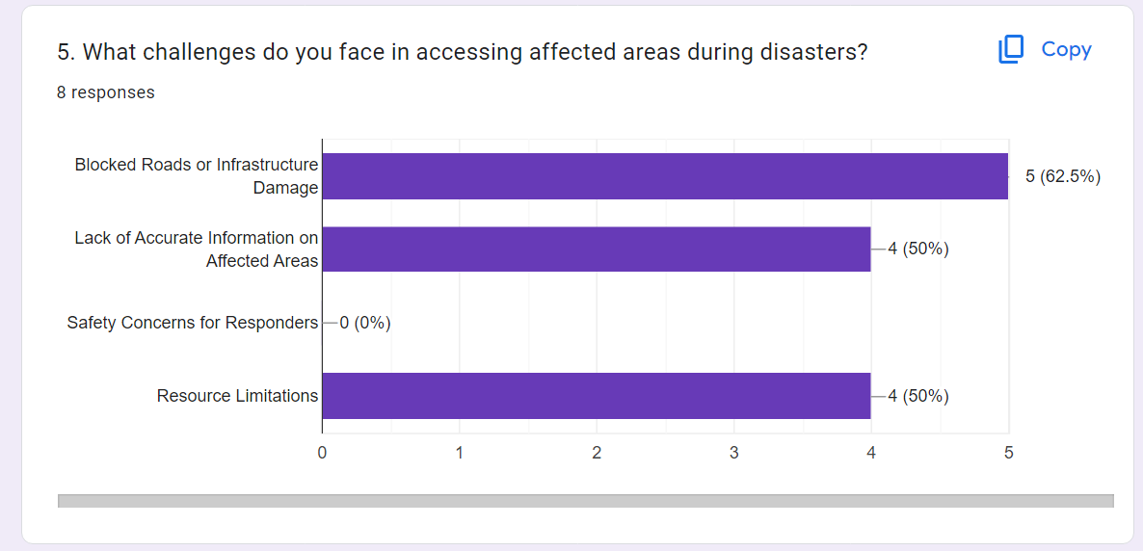

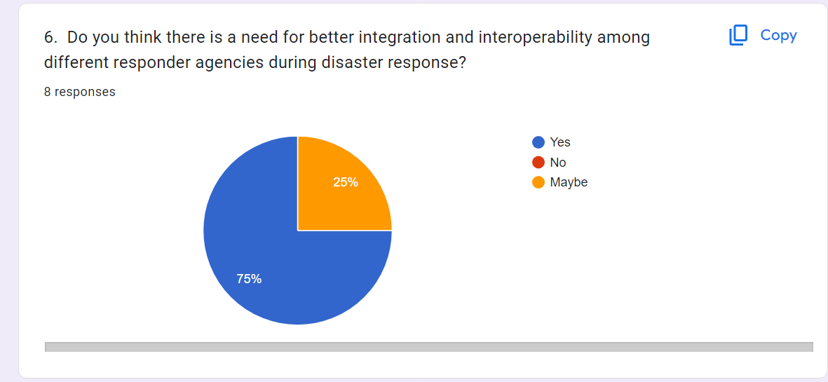

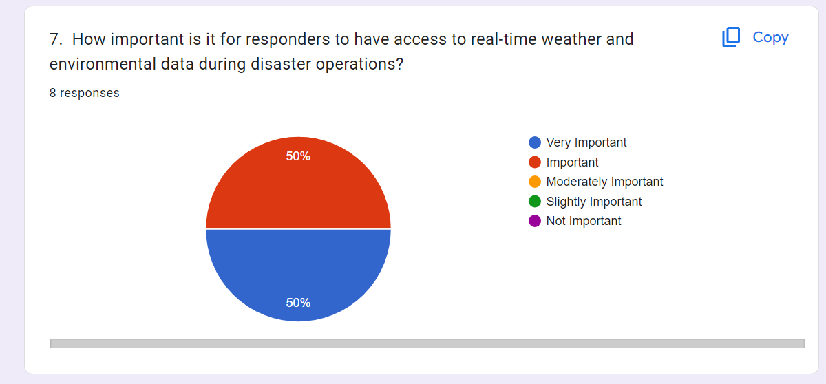

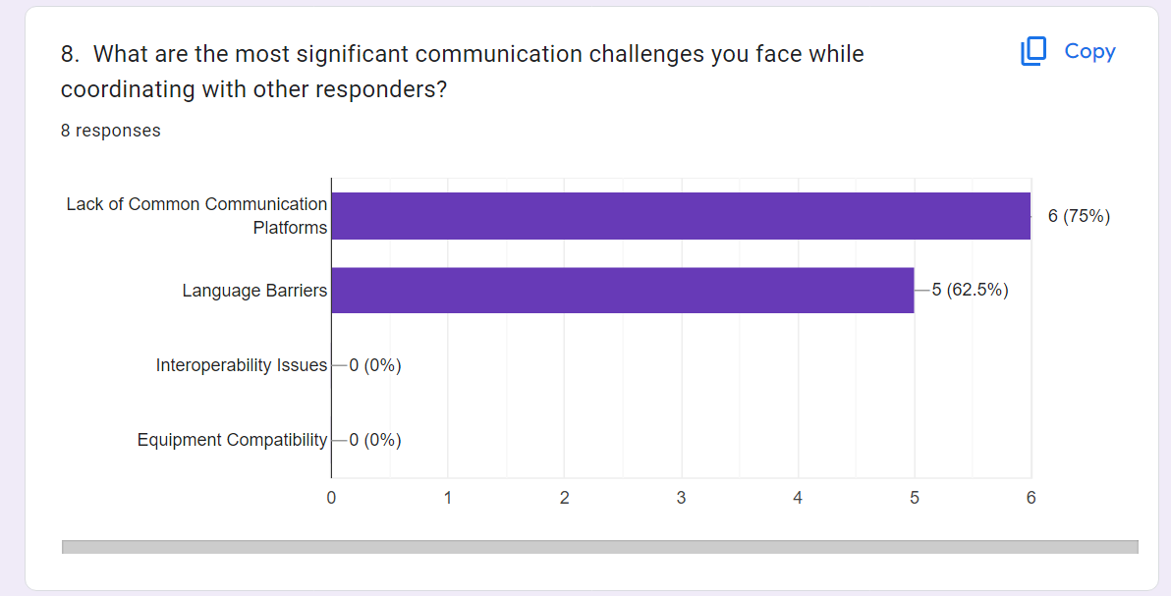

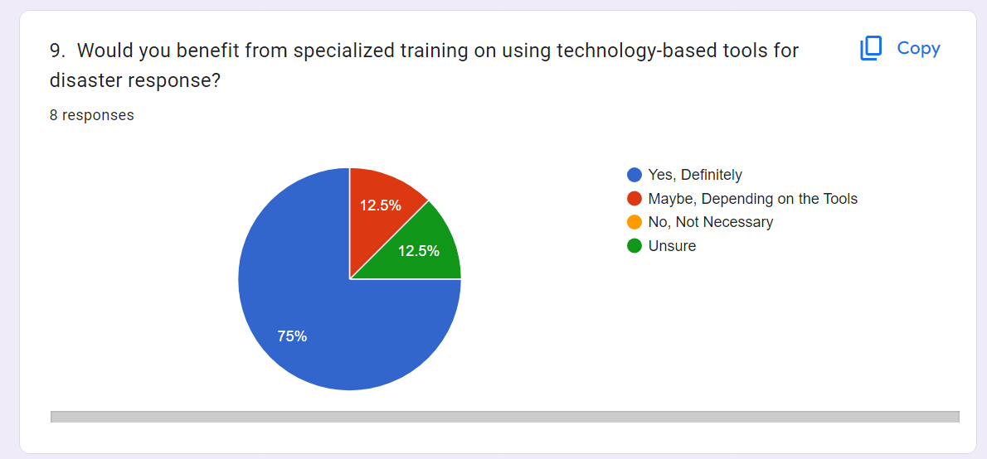

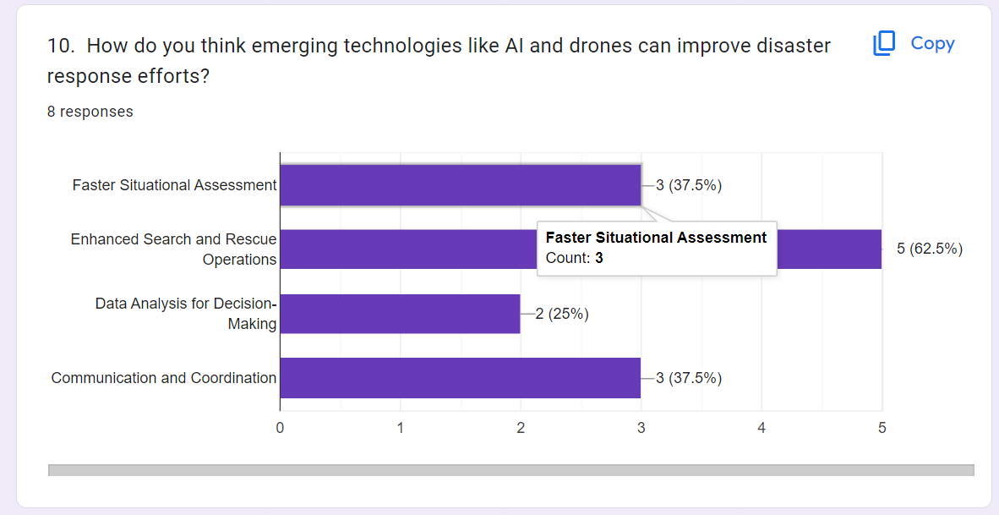

## **2.3 AUTHORITIES**

The data collected from our survey of authorities can be found here: [https://docs.google.com/spreadsheets/d/1as05Bwt17l2IdOpuYvPisQN9c_FHLPWA-Y_XkGV62t8/edit?resourcekey#gid=1377557347](https://docs.google.com/spreadsheets/d/1as05Bwt17l2IdOpuYvPisQN9c_FHLPWA-Y_XkGV62t8/edit?resourcekey" \l "gid=1377557347)

In our disaster management system, several authorities and organizations play essential roles in coordinating and implementing emergency response efforts. The specific authorities may vary depending on the country or region, but some of the authorities in our case include;

* The Government
* Medical Organizations: e.g World Health Organization

### **2.3.1 Features which they would Prioritize in the Disaster Management App**

* **Real-Time Data Analytics**: Robust real-time data analytics capabilities, allowing authorities to collect, analyze, and visualize data related to the disaster situation, response efforts, and resource utilization.
* **Emergency Alert System:** Incorporate an emergency alert system that enables authorities to send timely and targeted alerts, notifications, and warnings to the affected population and relevant response teams.
* **Resource Allocation and Tracking:** Provide features for authorities to allocate and track resources, including personnel, equipment, supplies, and facilities, to ensure efficient utilization and coordination among different response teams.
* **Communication Methods:** Integrate various communication methods, such as voice and video conferencing, instant messaging, and broadcast messaging, to facilitate seamless communication and coordination among authorities, response teams, and other relevant parties.

### **2.3.2 Challenges Faced**

The main issue talked about by authorities was Network Issues

### **2.3.3 Google Forms Summary For the Responses Gotten From Questions which were asked:**

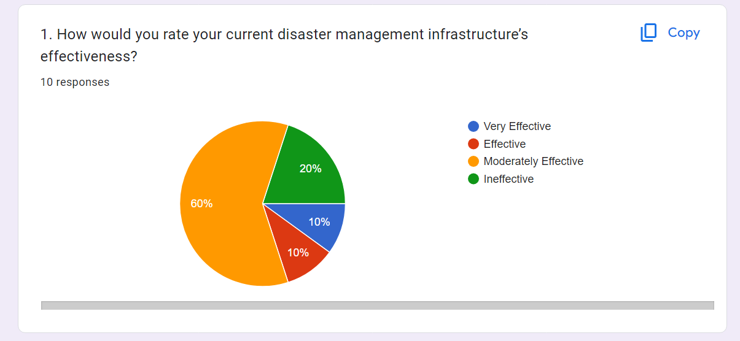

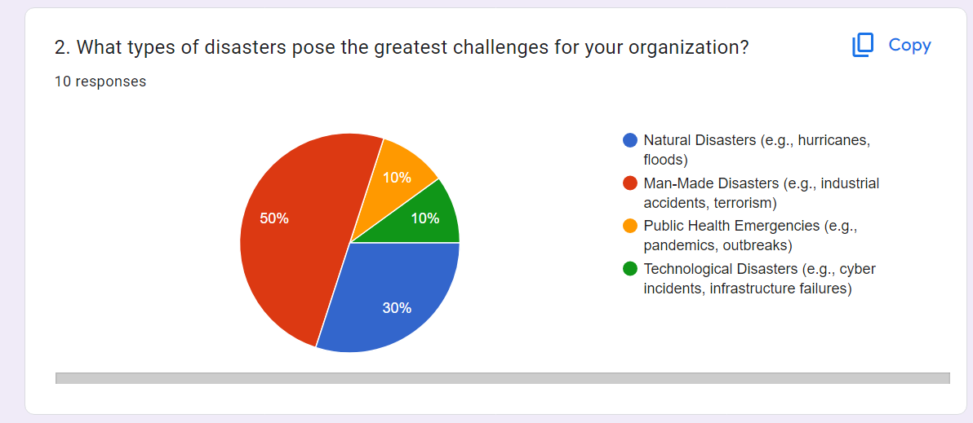

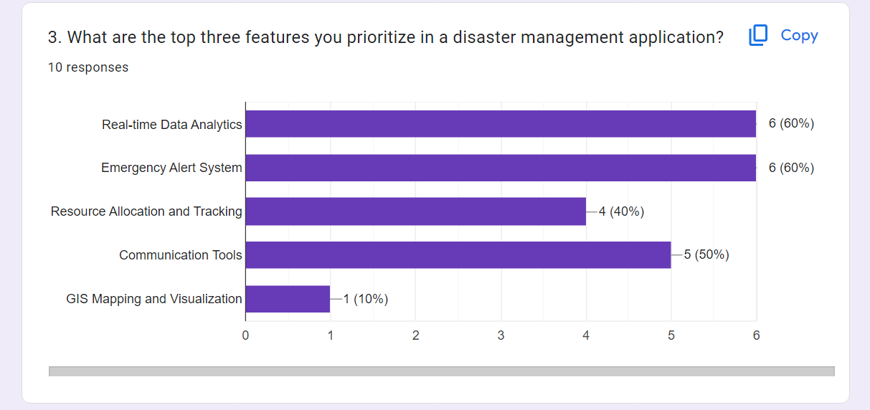

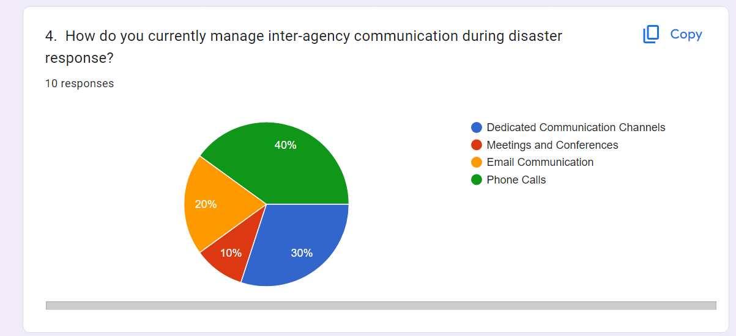

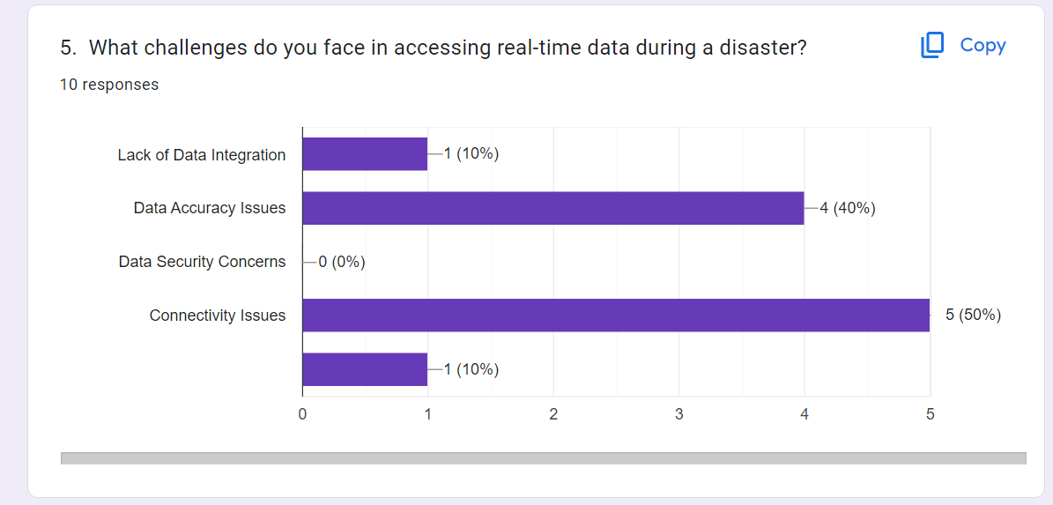

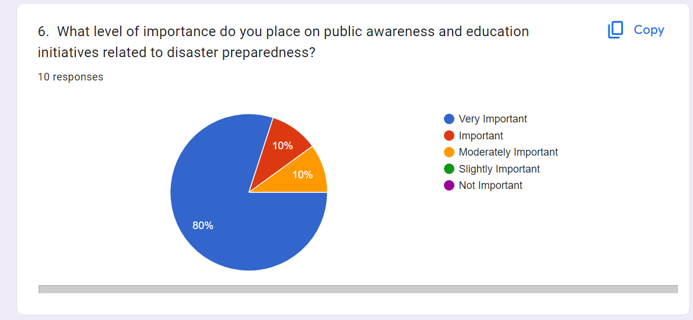

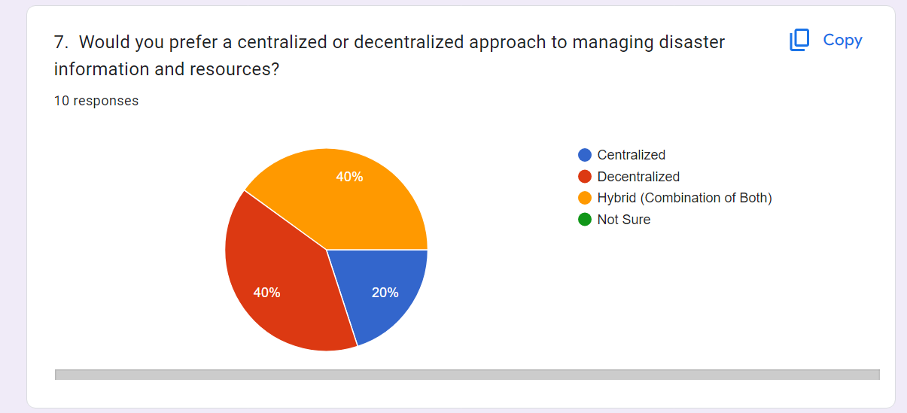

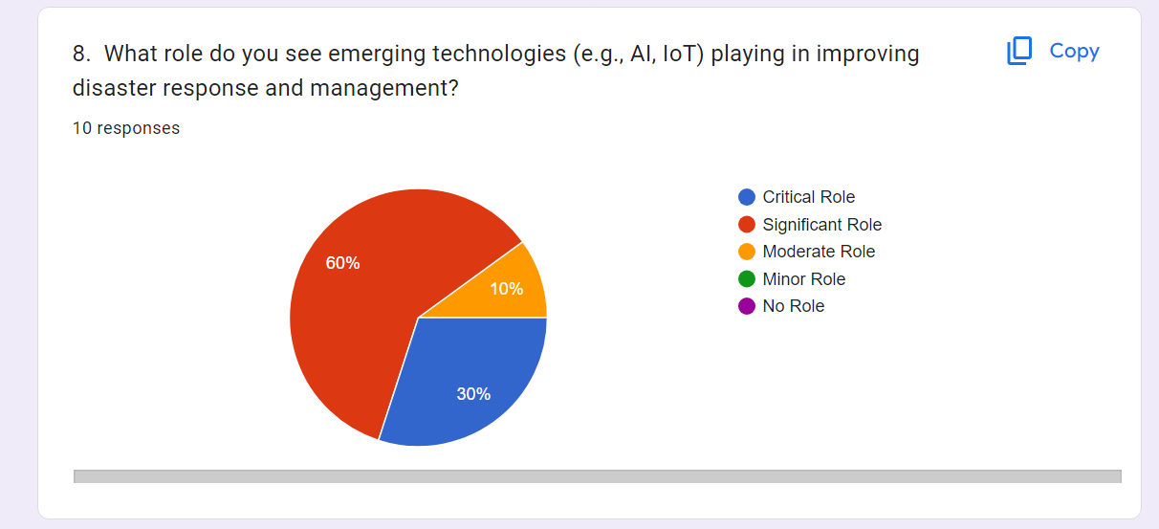

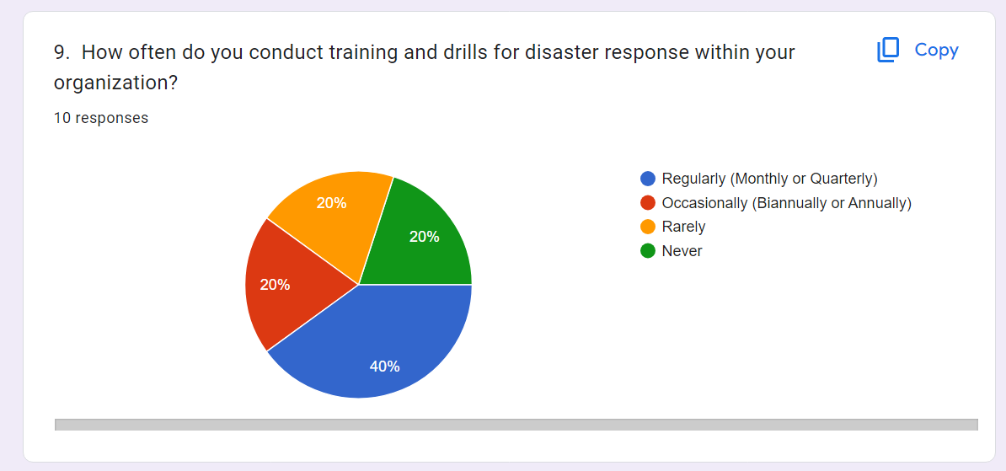

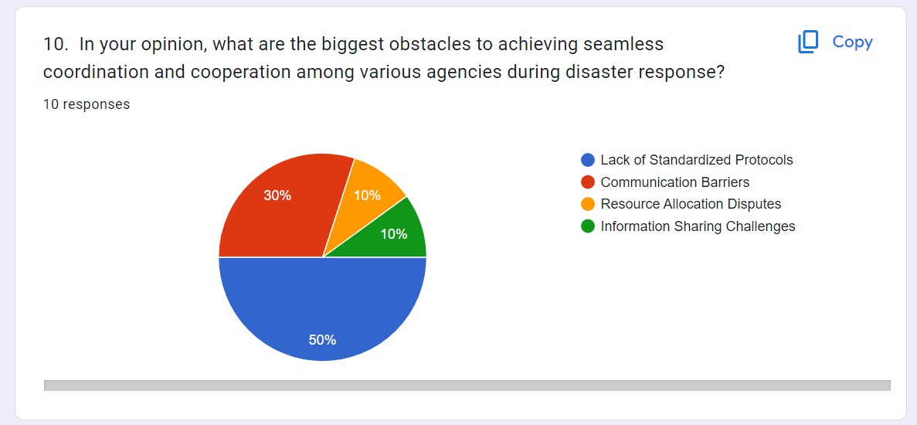

# **III - CONCLUSION**

In conclusion, developing a disaster management application with prioritized features is crucial for addressing the challenges faced by authorities, victims, and respondents. Such an application can significantly improve disaster response and recovery efforts by enabling efficient communication, coordination, and resource allocation. The prioritized features should include real-time alerts, location-based services, incident reporting, and information dissemination. These features would enhance situational awareness, facilitate timely emergency notifications, and enable effective deployment of resources to affected areas.

For authorities, the application would streamline their decision-making process by providing them with accurate and up-to-date information on the disaster's impact, allowing them to allocate resources more effectively. It would also enable them to communicate and coordinate with other stakeholders, including emergency services, NGOs, and volunteers.

For victims, the application would serve as a lifeline by providing them with immediate access to critical information and assistance. Real-time alerts and location-based services would help them receive timely evacuation orders and locate nearby shelters or medical facilities. Incident reporting features would allow victims to request help or report their status, facilitating targeted relief efforts.

For respondents, such as emergency services and volunteers, the application would enable them to efficiently navigate disaster-affected areas, respond to incidents, and provide aid where it is most needed. They could receive incident reports, prioritize their response based on severity and proximity, and collaborate with other responders through the application's communication channels.

However, there are challenges to overcome in developing such an application. These include ensuring reliable network connectivity during disasters, addressing privacy concerns, and promoting widespread adoption and usage among the target audience. Authorities need to collaborate with technology providers, telecommunication companies, and relevant stakeholders to overcome these challenges and create a robust disaster management application that effectively serves all parties involved.

In summary, a well-designed disaster management application with prioritized features can significantly enhance disaster response efforts. By addressing the challenges faced by authorities, victims, and respondents, the application can improve coordination, communication, and resource allocation, ultimately saving lives and minimizing the impact of disasters.